A000-Afr-D R Congo-Songye-Mask with bird effigy-Scarified face-early 20th c

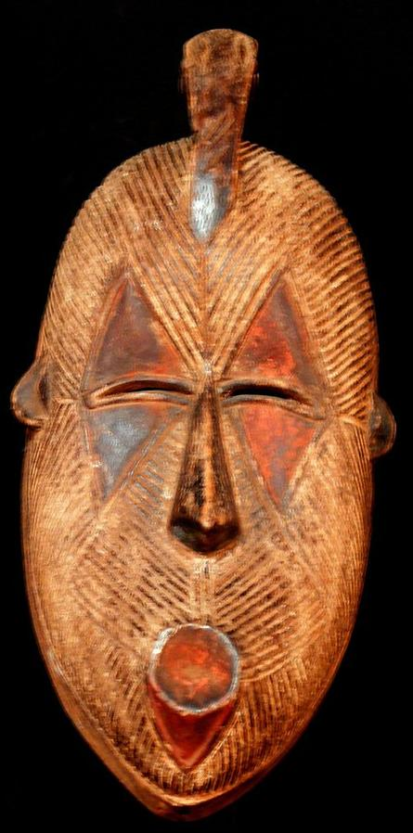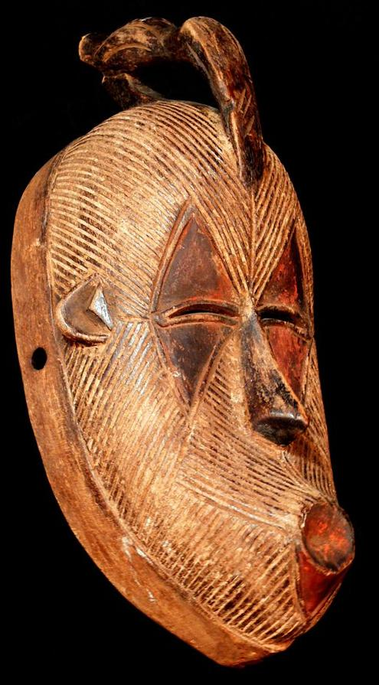

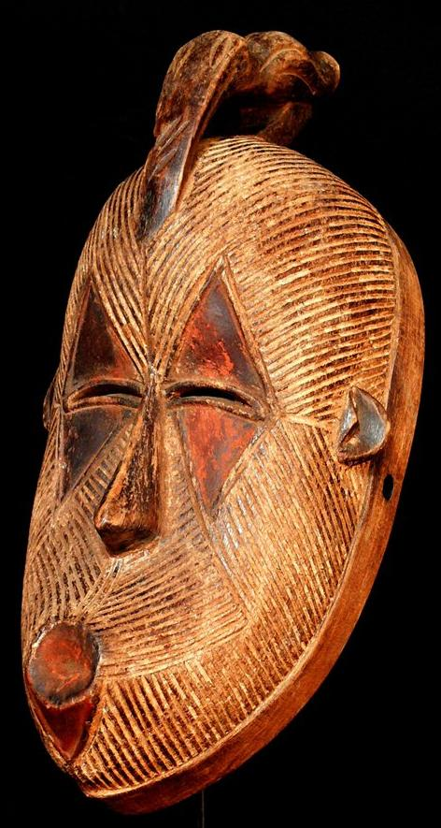 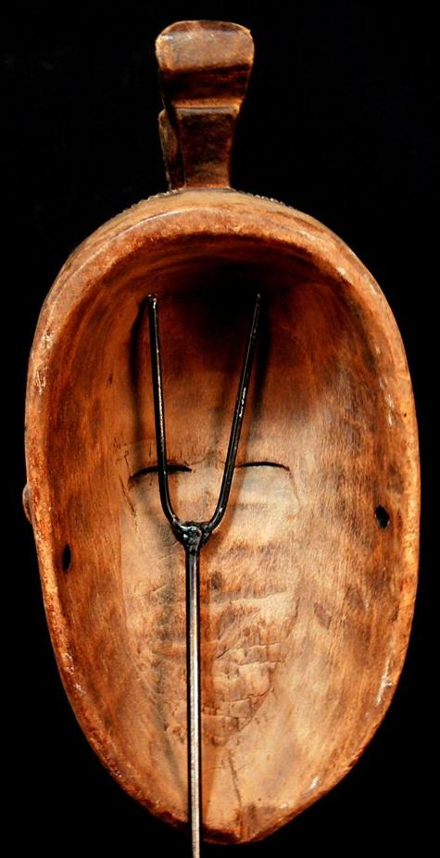

Figs. 1-4. D R Congo-Songye-Mask with bird effigy-Scarified face-early 20th c

Accession No.

Formal Label:

**Display Description:**

Accession Number:

**LC Classification:**

Date or Time Horizon:

Geographical Area:

**Map:**

**GPS coordinates:**

Cultural Affiliation:

Media: Wood, ochre pigment

Dimensions: H 13.77 in

Weight: 0.87 pounds

Condition: original

Provenance:

**Discussion:**

**References:**